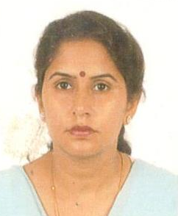

Mrs. Geeta Tandon
Senior Manager

Mrs. Geeta Tandon, has 25+ years of working experience in NITCON. She started her career as a Computer Operator and was associated in preparation of various project reports and feasibility studies.
She upgraded her qualification & skills and took active involvement in execution of Entrepreneurship Development Programmes (EDPs), Awareness Programmes, Capacity Building Programmes and Skill Development Programmes, for various target groups. She takes lectures in EDP training programmes on various topics including women empowerment.
She is also looking after MIS function and is a single source for compilation of all training related data/ documents starting from preparation of proposals till successful closure of the project.
She is B.Com., MBA, (HR) and has undergone certificate courses in Computers.

